Odoo Task
This is simple database that implements two tables patiant and visit with Many to one relation ,
with viwes that contanin a menu , action , form and tree

*Scaffold Command
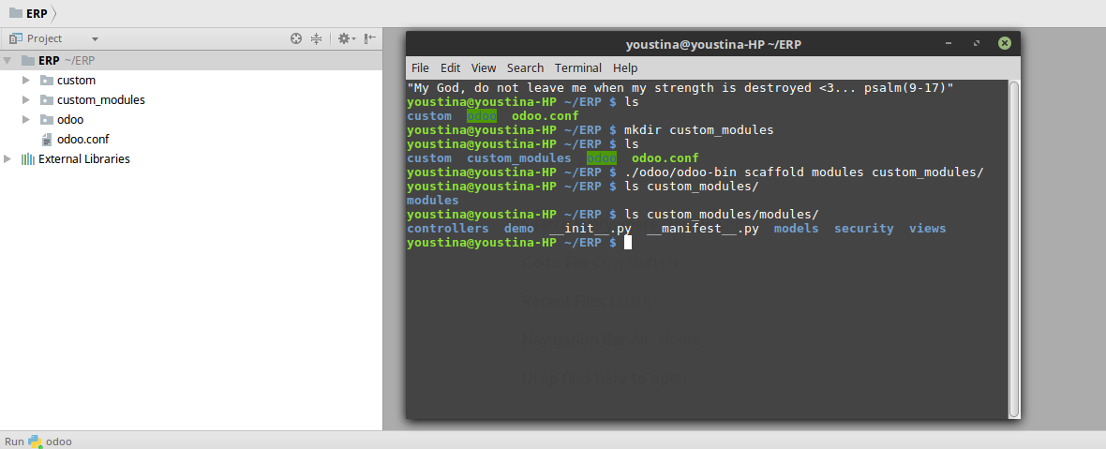
*Database
- visit table
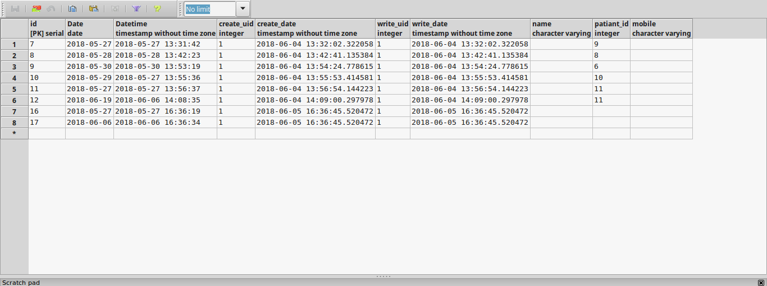
- patiant table
